**Develop Group Competition 1**

**Maze**

Input：standard input

Output：standard output

There is a maze with n x n rooms, 1≤n≤100. There may or may not be a door between two rooms. The room are indexed by (x,y) 1≤x,y≤n.

For example, the following is a 3 x 3 maze, there is a door between room (1,1) and room (1,2)

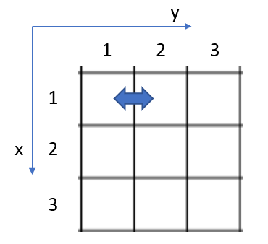

Your task is select a room (anyone) as a start point and travel as many rooms as possible through the door, the rule is you can only come into a room once.

**Input**

The first line contains one integer n (1≤n≤100)

Each of next 2n-1 lines describe the doors from left to right, 0 means “no door”, 1 means “have a door”.

**Output**

The rooms in the path, as format (1,1)(1,2)(1,3)…

**Example**

|  |  |
| --- | --- |
| Input:  3  1 1  0 1 0  0 0  0 1 0  1 1 |  |
| Output:  (1,1)(1,2)(2,2)(3,2)(3,3) |

Note, the answer is not unique, like (1,3)(1,2)(2,2)(3,2)(3,1) is also travelling 5 rooms, thus as good as the output in above table.

（中文版）开发组比赛题1

**迷宫**

输入：standard input

输出：standard output

迷宫有n x n 个房间， 1≤n≤100。 两房间之间有可能有门，也可能没有门。 房间用(x,y)标识， 1≤x,y≤n.

例如, 下面是一个3 x 3 迷宫，房间(1,1) 和(1,2)之间有一个门，其余房间之间都没有门。



你的任务是，选择任意一个房间为起点，通过门走到另外一个相邻房间，同一房间只能进入一次，走过的房间个数多者获胜.

**输入**

第一行只有一个整数 n (1≤n≤100)

接下来的2n-1 行描述了两个相邻房间之间的门是否存在，0 表示不存在, 1 表示存在。

**输出**

按顺序输出各房间索引，格式为 (1,1)(1,2)(1,3)…

**举例**

|  |  |
| --- | --- |
| 输入:  3  1 1  0 1 0  0 0  0 1 0  1 1 |  |
| 输出:  (1,1)(1,2)(2,2)(3,2)(3,3) |

注意, 答案不唯一, 像 (1,3)(1,2)(2,2)(3,2)(3,1) 也通过了5个房间, 所以和上面表格中的答案同样正确。